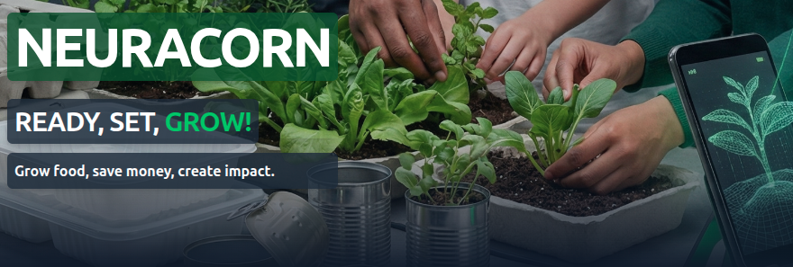
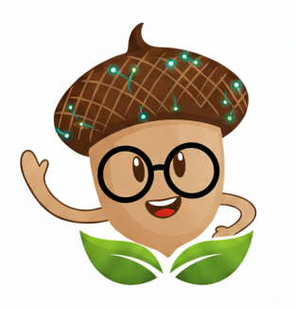 | PRIVACY BY DESIGN  School Pilot – Privacy & Data Statement  Plain language. No jargon. Designed for schools.  Generated: 17 Feb 2026

We don’t collect identity  - No names  - No emails  - No phone numbers  - No student accounts | Built for schools  - Teacher operated device  - Plant only photos  - No chat / social  - No ads / tracking | 30 - day deletion  • Pilot data deleted (30 days)  • EU storage  • Data not sold or shared

Why are we running this pilot?
This pilot is about learning. We want to understand whether children can use the app to learn how to grow food, whether it builds confidence, and how it fits into a real classroom. If schools find it useful, we may run more than one growing season. The goal is to improve it properly — not to rush it.

What is the project trying to do?
1) Teach people to grow food
Start simple.
Let them progress at their own pace.

2) Build confidence
Growing something successfully changes how a person feels about their own ability.
Confidence matters. Long-term change comes from steady shifts in attitude.

The outcome we’re aiming for
Learnable, practical, enjoyable.
Something children can take home and lead on.
The child becoming the teacher would be a fantastic outcome.

How the pilot works in school
In plain terms
Used on a teacher-operated device.
Children do not need phones.
No student accounts.
No chat, messaging, or social features.
No advertising.
Plant-only photos (no children, no faces, no identifying information).

What data do we collect?
Only plant data
We only collect data about the plants growing.
We do not collect names, emails, phone numbers, or personal profiles.
We do not collect marketing data.

What do we record instead?
What we record
Plant type and dates
Growth progress
Plant photos submitted for verification
The general part of the world the plant is growing in

Why we record it
To prove the crop genuinely grew.
To calculate biomass and CO₂ captured.
To infer the impact that might have on a typical shopping cart and the supply chain behind it.

Devices — not identities
We record devices, not people.
Example: 20 different logins from one device suggests someone is trying to game the system.
Example: 200 logins from one IP address suggests automated abuse.
We are protecting fairness. We are not tracking people.

Location – explained simply
General location only
We use general location to check that plant growth matches daylight and climate conditions.
For schools, this can be coarse (school-level area rather than exact positioning).
It is not used to track movement or identify children.

Where is data stored?
Storage
EU-based infrastructure.
Access limited to the pilot team.
Data is not sold.

How long is data kept?
Retention
Pilot data is kept only for the duration of the pilot and preparation of a short summary for schools.
After the pilot ends, all pilot data is deleted within 30 days unless a school asks us to retain it for operational reasons.
This pilot web app will later be replaced by a successor Android app with full terms and conditions.

Contact: pilot@neuracorn.com
Short version: We verify plants. We do not profile people.

